Sustainability Project / Team Three / Safe-House

**The Concept**

One of the principles of sustainability is gender equality.

[graphic of sustainability goals]

And in a gender-equal world, women would be able to live alone if they want.

[selfie photo of me and Bagsy]

And they would be able to do it safely, or at least with a minimum of risk.

So, what is the biggest risk to women? Statistically speaking[1], it’s the men we know and love, and the ones we don’t love any more.

[graphic?]

What if there were some way to know if someone I **used to trust** was standing outside my window at 3 o’clock in the morning about a week after a nasty breakup?

**Well, my creepy ex always has his phone in his pocket. And if he’s close enough to bother me, then he’s close enough to automatically connect to my wi-fi, right?**

**And now, my wi-fi network can tell me when that happens.**

Let’s watch that, shall we?

I’m going to explain how all of this in a moment, but right now, just trust me that I’m simulating what happens when my ex-boyfriend’s phone connects to my wi-fi.

[SAFE HOME CAUSES A RUCKUS]

**[STOP THE RUCKUS]**

If that happened at 3am, that would wake me up.

Suppose we set up a script to get the MAC[2] addresses from my router’s DHCP[3] client list and then put that information as a payload where the feather HUZZAH can grab it and compare it to a list of “bad guys.”[4]

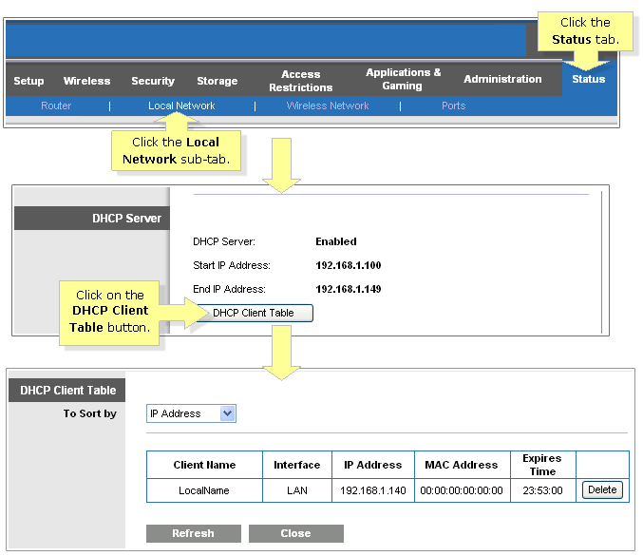

**Taken from: http://cache-www.linksys.com/support/images/KB17346-003_EN_v6.PNG**

Here is how the DHCP list looks when everything is okay…

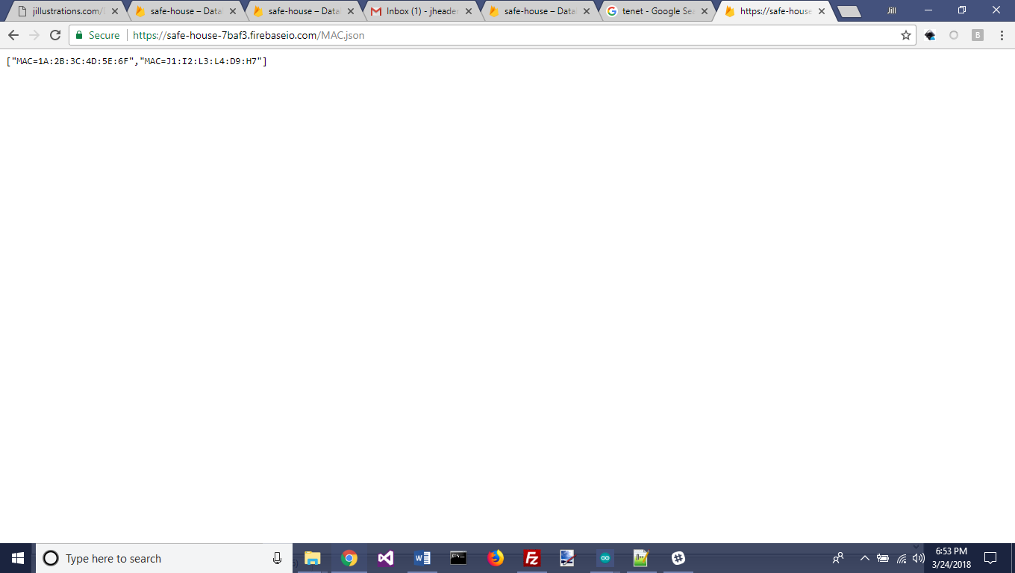

And here is a list of MAC addresses with an undesirable on there…

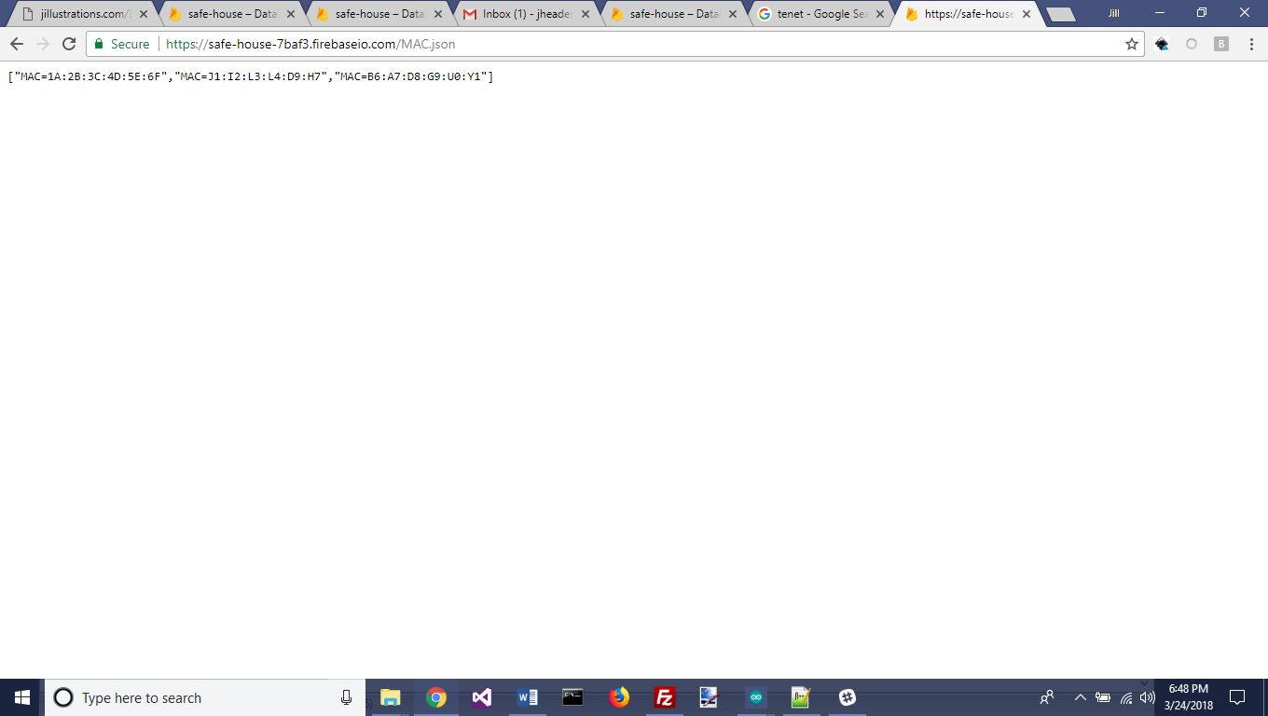

The feather HUZZAH pings the DHCP list, grabs the MAC addresses for every device connected, and if there’s a match between the list of who all is connected and who is listed on the Bad Guy list, Safe-Home lets me know.

**The App**

We have the prototype of an app to make maintaining your list of bad guys easy. And the app is designed with security in mind, in case your future ex looks through your phone **before** you’ve had the “It’s not me, it’s you” talk.

**Sustainable Future**

**Known Limitations:**

* Potential victim doesn’t have a wi-fi router
* Assailant loses/replaces phone, new MAC address is not on the Bad Guy list.
* Assailant knows to turn off the phone’s wi-fi - mitigation: this fact could be captured and submitted later as evidence whatever he did was premeditated.
* Bad Guy’s MAC address is not in “Bad Guy” list because I didn’t capture it when I had the chance – mitigation: write a script to send me a message whenever I give someone access to my wi-fi. MAC address can be associated with contact in my phone.

**Potential Improvements:**

Panic Button

1. According to the Center for Disease Control (CDC): “Homicide is one of the leading causes of death for women aged ≤44 years, and rates vary by race/ethnicity. Nearly half of female victims are killed by a current or former male intimate partner.” Source: https://www.cdc.gov/mmwr/volumes/66/wr/mm6628a1.htm
2. Why MAC addresses instead of IP addresses? Because IP addresses can change.
3. DHCP (Dynamic Host Configuration Protocol) is a network management protocol used to dynamically assign an Internet Protocol (IP) address to any device, or node, on a network so they can communicate using IP. Source: http://searchnetworking.techtarget.com/definition/DHCP
4. Or whoever your archenemies are.